1. Cover Letter
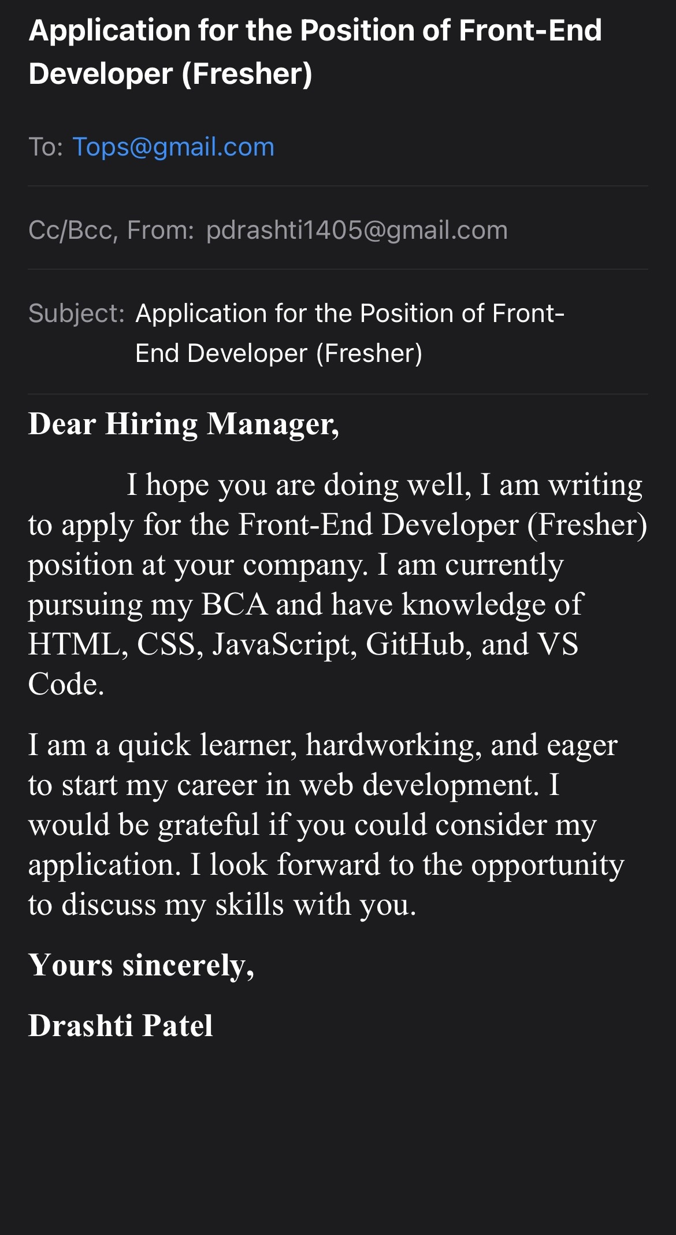

2. Portfolio
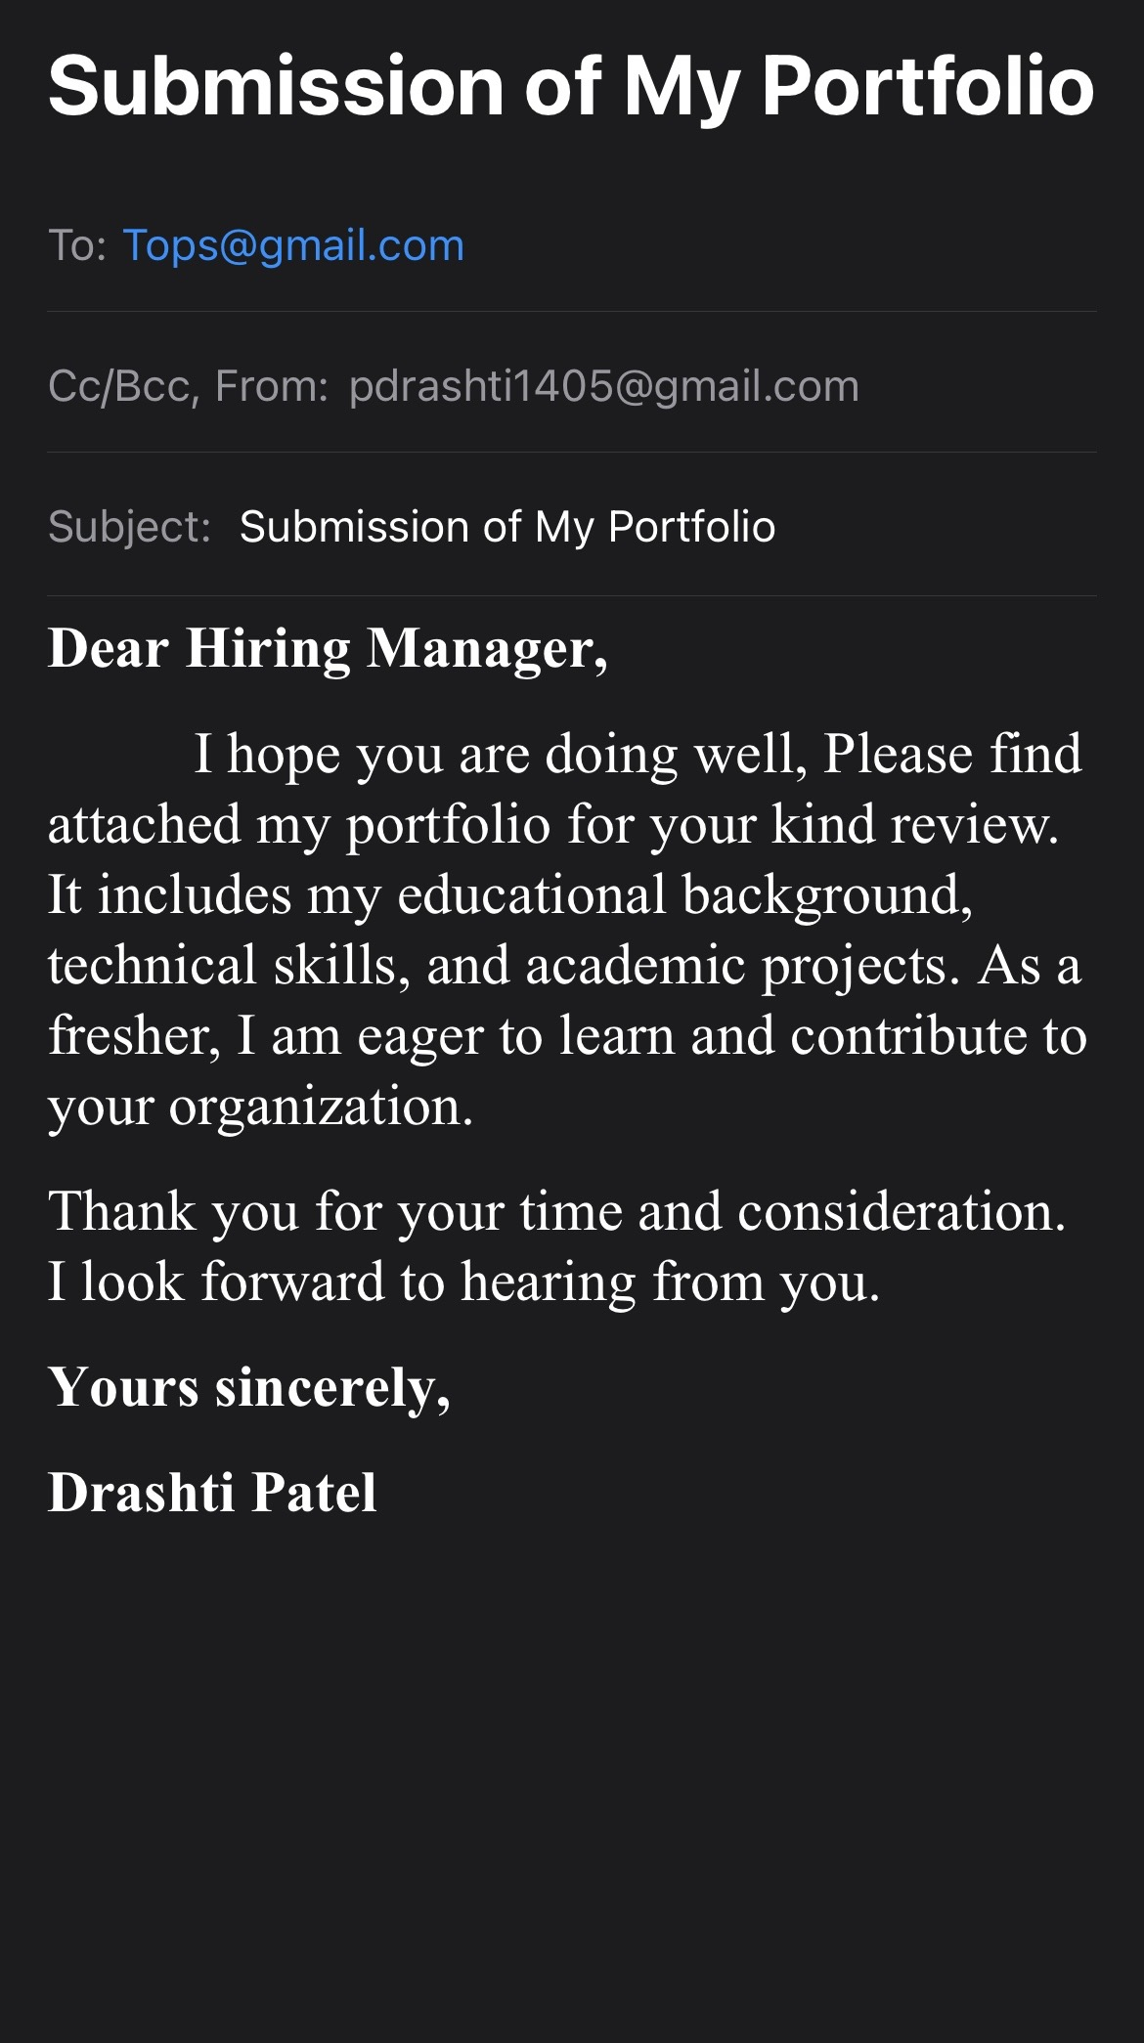

3. Recommendation Letter / Letter of Appreciation
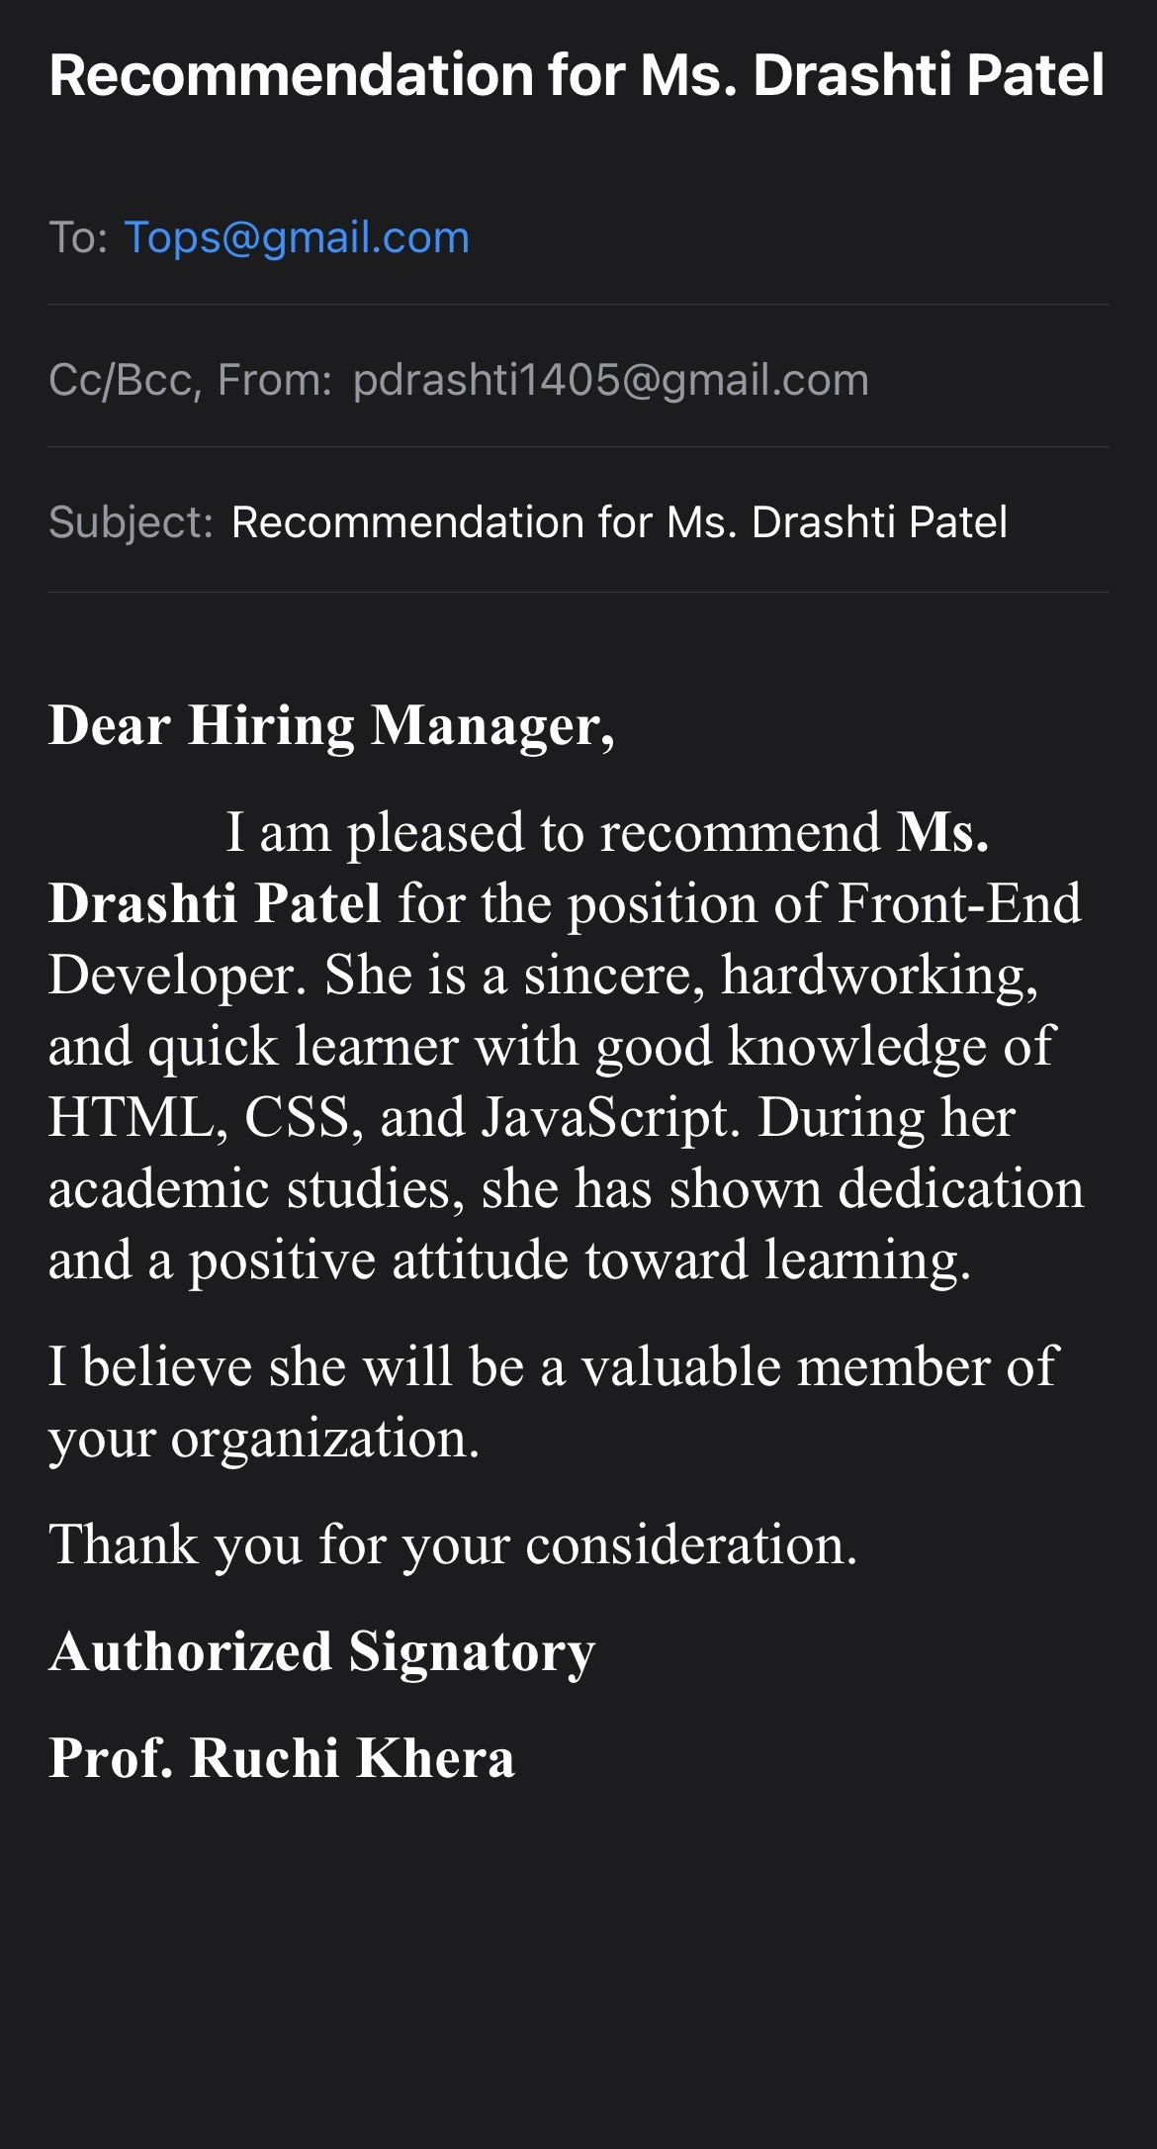

4. Experience Certificate / Employment Verification Letter
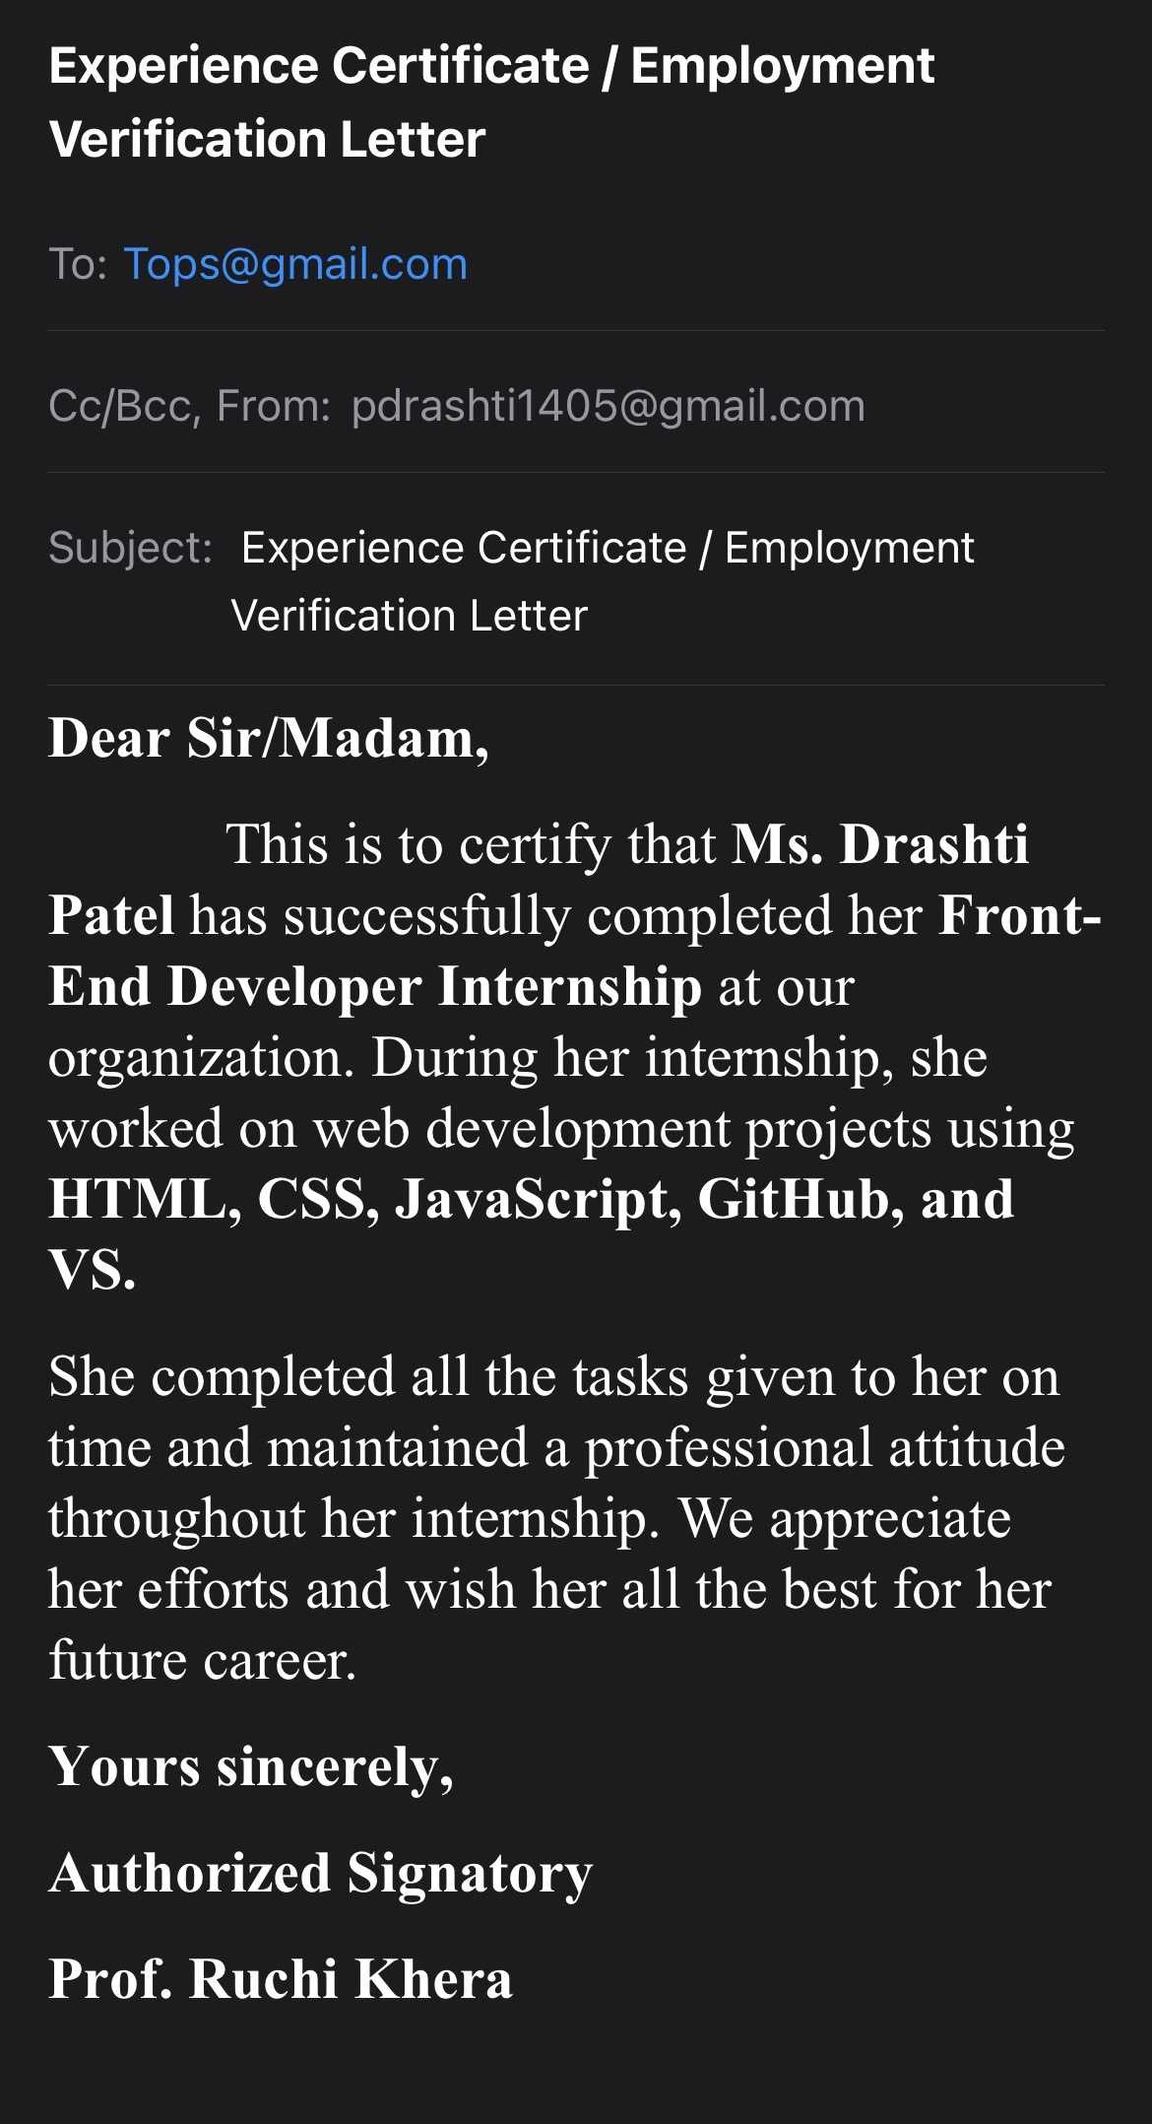

5. Letter of Interest (in a Job)
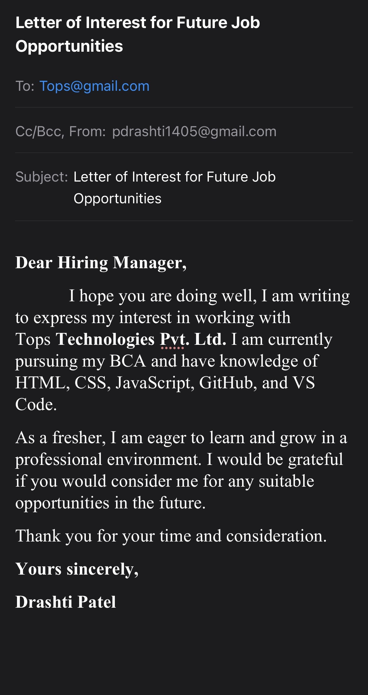

6. Follow-up Letter (after the Interview)
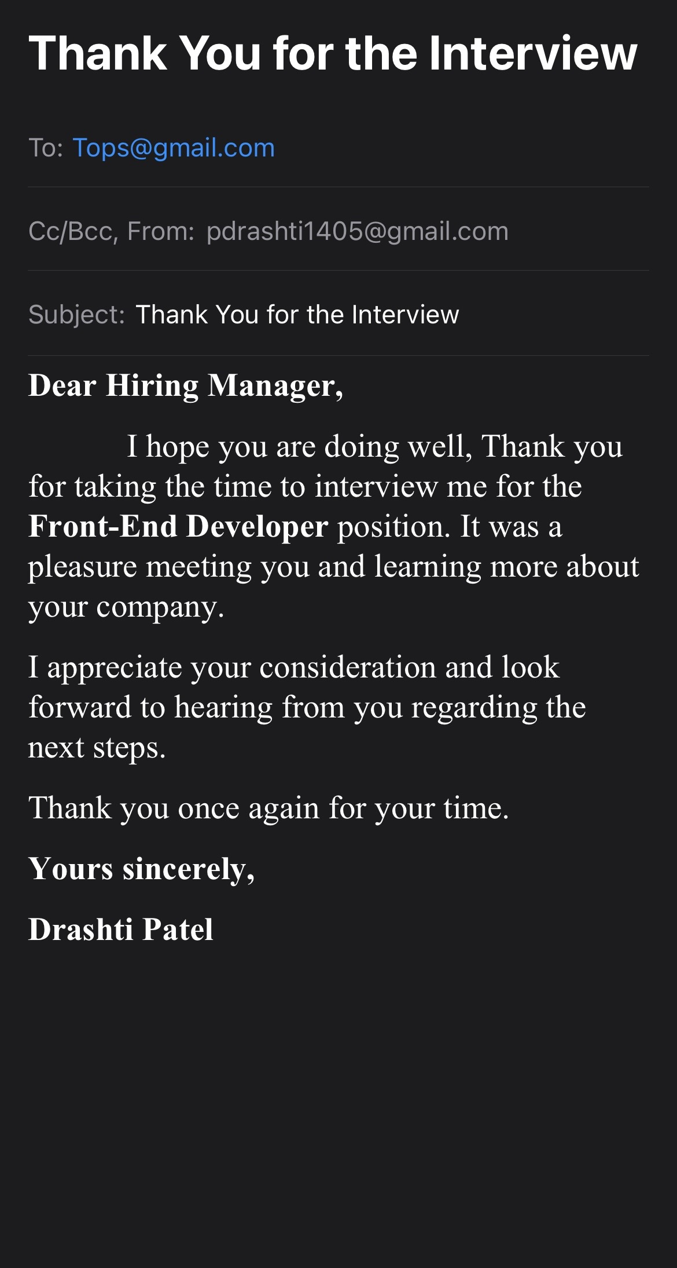

7. Acceptance Letter (after Receiving a Job Offer)
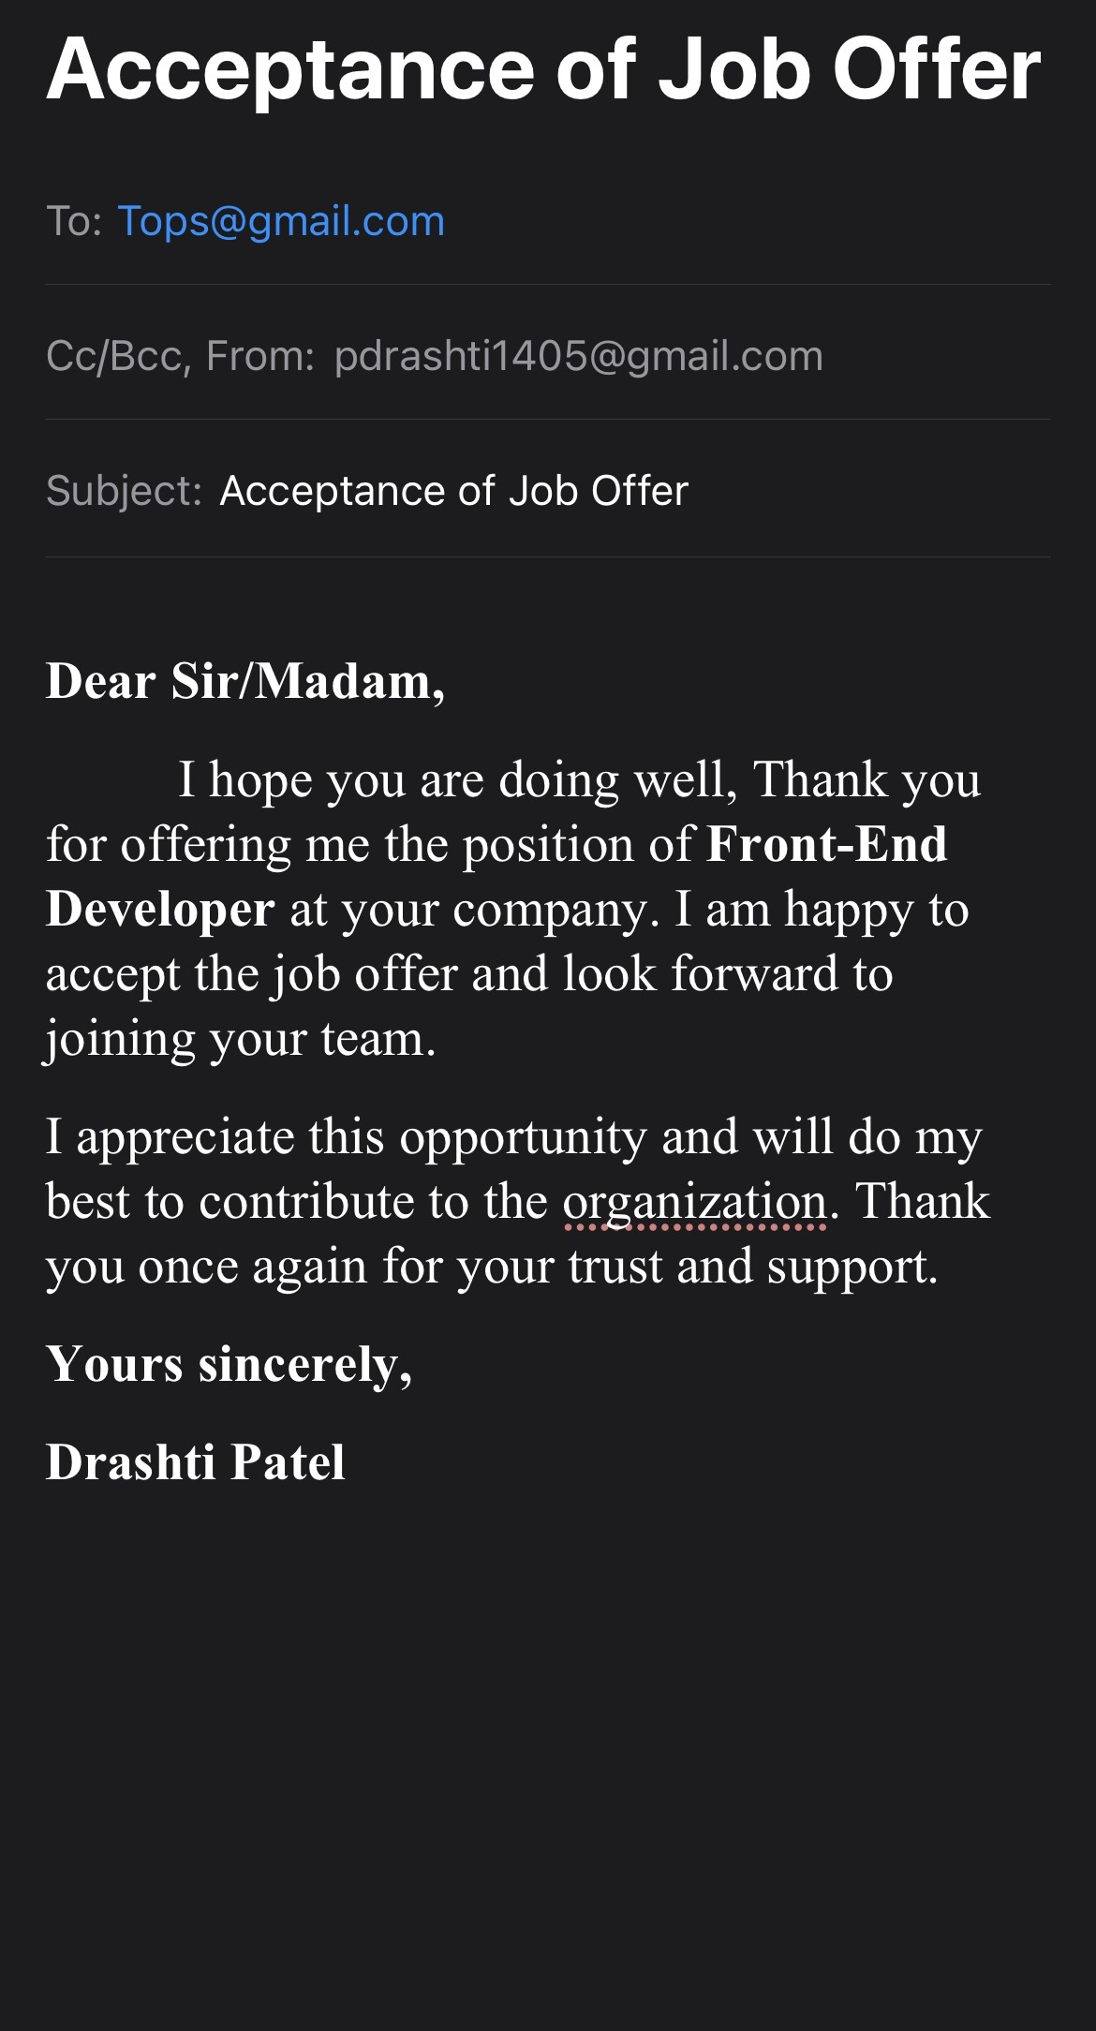

8. Declination Letter (after Receiving a Job Offer)
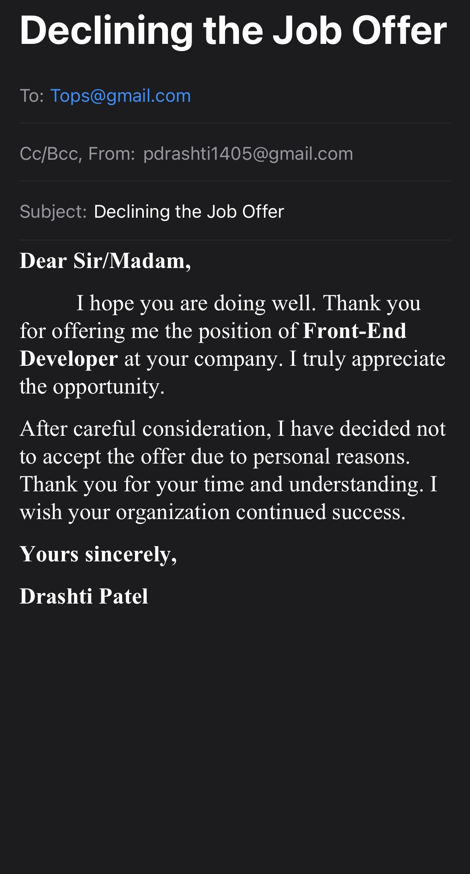

9. Leave-of-absence Request Letter
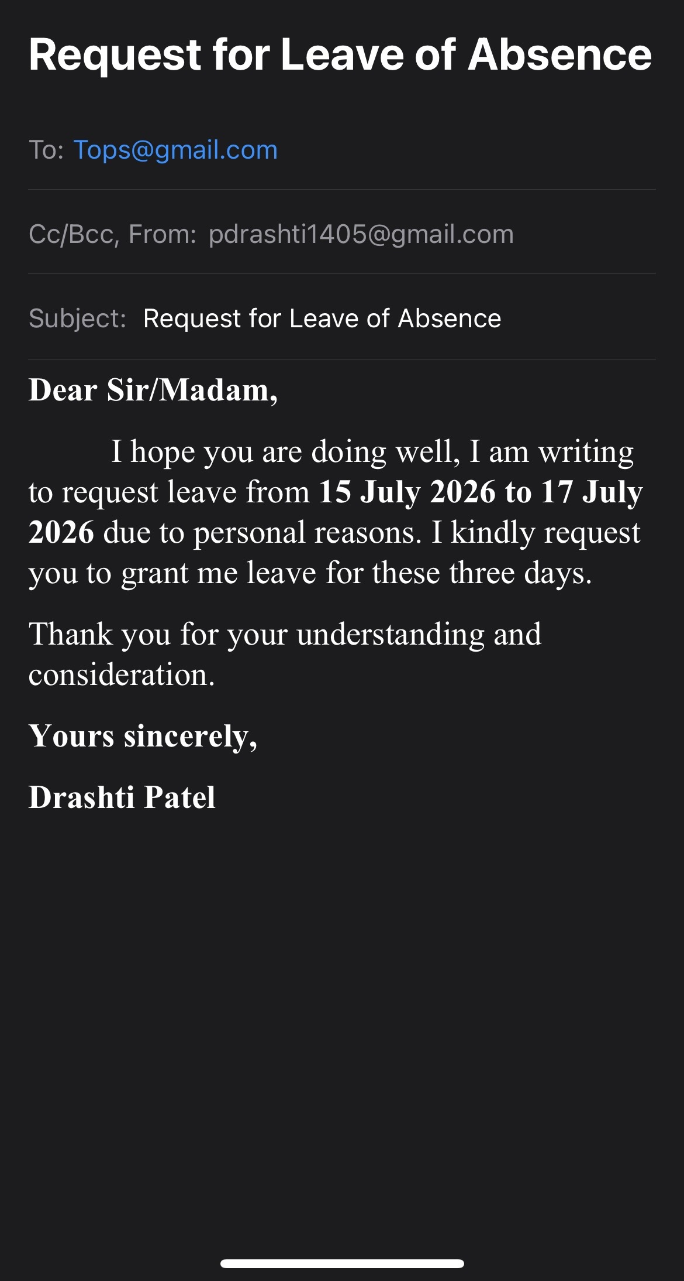

10. Resignation Letter
